Zero Trust Network Access Control Architecture v3

Outcomes, Technical Enforcement, and Delivery

Author
Michael J. Martin, Lead Director, Information Security
Date
March 23, 2026
Classification
Confidential

Table of Contents
1. Executive Overview 4
2. Program Outcomes and Deliverables 5
2.1 Security Outcomes 5
2.2 Operational Outcomes 6
2.3 Strategic Outcomes 6
3. Architecture Foundation 8
3.1 Design Principles 8
3.2 Authoritative Trust Sources 9
3.3 Policy Precedence Model 10
4. Device Classification and Posture Model 12
4.1 Device Classification 12
4.2 Three-Tier Posture Framework 12
5. Technical Enforcement Model 14
5.1 RADIUS MAB Authorization 14
5.2 Change of Authorization 15
5.3 Restricted Egress 17
5.4 Per-Client Enforcement on Shared Uplinks 19
5.5 Fallback Enforcement 20
5.6 Identity Hardening 21
6. Observability and Governance 22
6.1 SIEM Correlation Model 22
6.2 Exception and Break-Glass Management 23
6.3 Key Performance Indicators 23
7. Failure Modes and Resilience 24
7.1 MDM Unavailable 24
7.2 EDR Unavailable 25
7.3 NAC Platform Unavailable 25
7.4 CoA Path Degraded 25
7.5 Governing Principle 25
8. IoT and OT Governance Lifecycle 27
8.1 Phase 1 — Discovery and Profiling (Months 1–6) 27
8.2 Phase 2 — Baseline Governance (Months 6–18) 27
8.3 Phase 3 — Continuous Validation (Months 18+) 28
9. Delivery Plan 29
9.1 Short-Term Delivery: Foundation and Pilot (Months 1–9) 29
Phase 1 — Foundation and Integration (Months 1–3) 29
Phase 2 — Enforcement Pilot (Months 4–6) 29
Phase 3 — Core Site Production Rollout (Months 7–9) 30
9.2 Long-Term Delivery: Expansion and Maturity (Months 10–36) 30
Phase 4 — Specialty Location Expansion (Months 10–24) 30
Phase 5 — Optimization and Evolution (Months 12–36, overlapping) 31
9.3 Evolution Roadmap 31
10. Risk Register 33
11. Organizational Readiness 34
11.1 Network Team Preparation 34
11.2 Security Tool Health 34
11.3 Helpdesk and SOC Readiness 34
11.4 Executive Sponsorship 34
11.5 Phased Enforcement Activation 35
11.6 Resource Requirements 35

1. Executive Overview
This document defines the authoritative architecture for a Zero Trust-aligned Network Access Control program. The program replaces implicit, location-based trust with continuous, identity- and posture-driven authorization enforced at the network edge. The NAC platform — Forescout — serves as the central RADIUS policy engine, integrating with Microsoft Intune and Jamf Pro for device management authority, CrowdStrike Falcon for runtime endpoint security, Qualys and Tanium for vulnerability and configuration compliance, and Zscaler Internet Access for universal internet brokerage.
The architecture is designed for enterprise environments where the wireless LAN platform cannot natively enforce admission or post-admission NAC policy. Rather than depending on access points or wireless controllers, the design moves enforcement to the first controllable hop: the access switch. Enforcement is applied per device using RADIUS MAC Authentication Bypass with continuous posture evaluation and Change of Authorization for runtime policy adjustment. The existing VLAN structure and network topology remain unchanged.
The program addresses corporate, retail, and distribution environments through a phased rollout, beginning with 30 core corporate and back-office locations and expanding to specialty environments as operational patterns and controls mature.

2. Program Outcomes and Deliverables

2.1 Security Outcomes
Elimination of location-based trust. Every device's network access is conditional, time-bound, and revocable based on live authoritative signals rather than network location or static credentials. The NAC architecture ensures that a device's physical or logical position on the network confers no inherent trust. Whether a device connects from a corporate office, a retail back-office, or a distribution center, access is granted only when the device satisfies continuously evaluated posture requirements. If those requirements cease to be met at any point during the session, access is immediately adjusted or revoked through Change of Authorization.
Lateral movement prevention. Compromised, unmanaged, or non-compliant devices cannot reach internal resources or move east-west across the network. When a device fails posture evaluation, it is placed into a Restricted Egress state that permits only the minimum connectivity needed for remediation — DNS, DHCP, MDM management planes, EDR cloud services, and internet access through Zscaler — while denying all internal RFC1918 traffic. This design eliminates the most common attack progression path: initial compromise followed by lateral discovery and exploitation of internal systems.
Continuous posture enforcement. Device security health is evaluated continuously using multiple authoritative sources including MDM compliance state, EDR sensor health, vulnerability scan results, configuration compliance, and internet threat telemetry. Access privileges expand or contract dynamically as posture changes, with a target campus-wide P95 posture-to-enforcement latency of 15 seconds. This represents a fundamental shift from point-in-time admission checks to a continuous authorization model that responds to security events in near real time.
Comprehensive device visibility. The program delivers a continuously updated inventory of all network-connected devices — managed endpoints, unknown devices, IT IoT, and OT IoT — classified by type, management status, and security posture. This inventory serves as an authoritative asset registry that feeds the CMDB, supports incident response with real-time device context, and satisfies compliance requirements for asset management and network segmentation controls.
Fail-safe degradation. The system never unintentionally fails open. When control-plane services are unavailable, new sessions default to Restricted Egress, existing sessions retain their last-known authorization, and all transitions generate alerts and SIEM events. This principle governs every failure mode in the architecture — MDM unavailability, EDR outages, NAC platform degradation, and CoA path impairment — ensuring that the enterprise's security posture degrades gracefully rather than catastrophically.

2.2 Operational Outcomes
Infrastructure preservation. The architecture requires no modifications to existing VLAN design, IP addressing, or network topology. Enforcement is achieved through dynamic ACLs applied within existing VLANs via RADIUS authorization. This is a critical design constraint that reduces deployment risk, eliminates the need for network redesign, and allows the program to be deployed incrementally across sites without disrupting established network services or requiring extensive change windows for infrastructure modifications.
Automated remediation and self-healing. Devices that resolve posture issues — install patches, re-enable agents, clear vulnerabilities — automatically regain standard access without helpdesk intervention. The NAC platform detects the posture improvement through its continuous monitoring integrations and issues a Change of Authorization to restore the device's access tier. This self-healing capability is projected to achieve a 60–80 percent reduction in access-related support requests, significantly reducing operational burden on helpdesk and desktop support teams.
Unified wired and wireless enforcement. A single policy framework applies consistently across wired switch ports and wireless SSID connections, eliminating configuration drift between access methods. Whether a device connects via Ethernet or Wi-Fi, the same posture evaluation, tier assignment, and enforcement logic apply. This unified model simplifies policy management, reduces the risk of enforcement gaps, and ensures that security controls do not vary based on the physical access method.
Reduced incident response time. Threat containment occurs within minutes of detection rather than hours required for manual processes. CrowdStrike detections trigger immediate network restriction via Change of Authorization, isolating compromised devices at the network layer while the SOC investigates. This automated containment capability transforms incident response from a manual, reactive process into an automated, proactive control that limits blast radius before human responders are engaged.
Auditable authorization. Every access decision is a formal RADIUS transaction with timestamps, device identifiers, named policy profiles, and documented MDM/EDR state at decision time. This produces end-to-end evidence for compliance and investigations, enabling the organization to demonstrate that every network access decision was made based on verified device identity and posture, with a complete audit trail from connection to disconnection.

2.3 Strategic Outcomes
Regulatory alignment. The architecture directly supports compliance with NIST 800-207 Zero Trust Architecture principles, PCI-DSS network segmentation requirements, HIPAA access control standards, and HITRUST CSF controls. By implementing continuous verification, least-privilege access, and comprehensive audit logging, the program provides demonstrable evidence of security controls that auditors and regulators expect in a modern enterprise environment.
Evolvable architecture. The design includes a clear enforcement evolution roadmap from per-session dynamic ACLs through role abstraction to SGT/TrustSec identity-based segmentation. Each phase builds on the previous one without changing the underlying trust model, protecting the organization's investment while enabling progressively more sophisticated and scalable enforcement as the program matures and hardware capabilities improve.
IoT/OT governance. The program establishes a structured three-phase lifecycle for IoT and OT device governance that builds an authoritative asset registry integrated with the CMDB. This registry supports incident response with real-time device context, compliance reporting with accurate asset inventories, and lifecycle management with vendor and firmware tracking. The phased approach — discovery, baseline governance, and continuous validation — ensures that operational disruption is minimized while security controls are progressively applied.
Policy-as-code foundation. The architecture enables version-controlled, reviewable, and reproducible policy changes with automated CI pipelines, diffs, approvals, and rollbacks. ACL definitions, allow-lists, and posture rules are treated as code artifacts subject to the same change management rigor as application code. This approach reduces configuration errors, enables rapid and safe policy iteration, and provides a complete audit trail of every policy change with associated approval records.

3. Architecture Foundation

3.1 Design Principles
Separation of admission and authorization. MAC Authentication Bypass provides basic network admission — confirming that a device is permitted to connect and establishing a session. Forescout provides continuous posture-based authorization that determines what the admitted device can access and adjusts those privileges over time as posture signals change. This separation ensures that the admission mechanism is simple and reliable while the authorization logic can be arbitrarily sophisticated.
Enforcement without topology change. Access control is implemented via switch and wireless ACLs and firewall policies, not VLAN segmentation or subnet redesign. The existing network topology remains intact. This principle dramatically reduces deployment complexity, eliminates the need for IP re-addressing, and allows enforcement to be activated incrementally on a per-site, per-VLAN basis.
Multi-source posture aggregation. Device trustworthiness is computed from DHCP fingerprints, MDM enrollment status, EDR health, vulnerability data, configuration compliance, and internet threat telemetry. No single source is sufficient; the aggregation of multiple signals produces a more accurate and resilient posture assessment that is resistant to single-source failures or manipulation.
Dynamic, reversible controls. Access restrictions are applied automatically when posture degrades and removed automatically when remediation completes. There is no manual unlock step. The system is designed to respond to posture changes in both directions — restriction and restoration — with equal speed and reliability, minimizing both security exposure and user disruption.
Risk-proportional enforcement. Strict posture-based controls apply to managed Windows and macOS endpoints, where the organization has the highest management authority and the greatest security expectations. Unknown Windows/macOS devices are denied by default, as their presence on the network without management enrollment represents an unacceptable risk. IoT and OT devices are discovered, classified, and governed progressively, reflecting the practical reality that these devices cannot run standard security agents.
Scoped discovery and enforcement. Discovery and enforcement are limited to explicitly defined network segments and device populations to manage licensing costs and focus investment on high-value targets. Not every VLAN or subnet requires NAC enforcement; the program defines clear scope boundaries and expands them deliberately as operational confidence grows.
MDM authority is decisive. A device is considered managed only when Intune or Jamf confirms live enrollment and compliance. No other signals — not SCCM inventory, EDR presence, certificates, or CMDB assertions — are authoritative for managed status. This bright-line rule eliminates ambiguity in the most critical classification decision the NAC makes.
CrowdStrike provides runtime assurance. A managed device must also have a healthy, tamper-protected sensor to qualify for standard access. EDR does not override MDM authority; it complements it. A device that is MDM-compliant but lacks a functional CrowdStrike sensor is placed into Restricted Egress until the sensor is restored.
ZIA is the universal internet broker. All enterprise endpoints route internet traffic through Zscaler Internet Access regardless of location, decoupling internet security from local egress. This ensures consistent threat protection, DLP enforcement, and visibility whether the device is on the corporate network or remote.
Enforcement at the access switch. The AP is treated as a transport element only. The access switch is the first controllable hop and the enforcement point. This design decision reflects the reality that wireless LAN platforms in the target environment cannot natively enforce post-admission NAC policy. By moving enforcement to the switch, the architecture gains access to RADIUS MAB, CoA, and per-client dACL capabilities that the AP does not provide.

3.2 Authoritative Trust Sources
The following table defines the authoritative trust sources that feed posture evaluation. Each source provides a specific category of security telemetry, and together they produce a comprehensive assessment of device trustworthiness.
Trust Source | Platform | Data Consumed | Role in Authorization
Device Management Authority | Microsoft Intune, Jamf Pro | Enrollment status, compliance state, last check-in, ownership, user attribution | Decisive authority for "managed" status. If MDM reports unenrolled or non-compliant, the device is not managed — no exceptions.
Runtime Security Health | CrowdStrike Falcon | Agent status, detection events, containment state, tamper status | Runtime integrity gate. Managed devices must also have a healthy sensor for standard access.
Vulnerability Posture | Qualys Cloud Agent | Vulnerability scan results, critical vulnerability count, patch status, asset risk score | Informs posture tier assignment. Critical vulnerabilities can trigger restriction even on otherwise healthy devices.
Configuration Compliance | Tanium XEM | Patch compliance, OS hardening baselines, unauthorized applications, configuration drift | Enforces patch and configuration standards. Persistent non-compliance triggers tier downgrade.
Internet Threat Telemetry | Zscaler ZIA | Client Connector posture, threat events, DLP violations, device risk score | Bidirectional integration: ZIA threats inform LAN restrictions; LAN posture informs SaaS access policy.
Network Identity | Forescout Platform | DHCP fingerprinting, ARP correlation, RADIUS accounting, passive profiling | Device classification and session correlation. Anchors MAC-to-IP binding for per-client enforcement.

3.3 Policy Precedence Model
MDM authority is decisive for managed status. If Intune or Jamf reports a device as unenrolled or non-compliant, the device is not managed for NAC purposes — no exceptions. CrowdStrike does not override this decision; a healthy EDR sensor on an unmanaged device does not grant standard access. Conversely, a managed device with an unhealthy or missing sensor also fails the standard-access gate and is placed into Restricted Egress. Both conditions — managed and healthy — must be satisfied simultaneously.
Figure: Policy Precedence — MDM Decisive, EDR Required
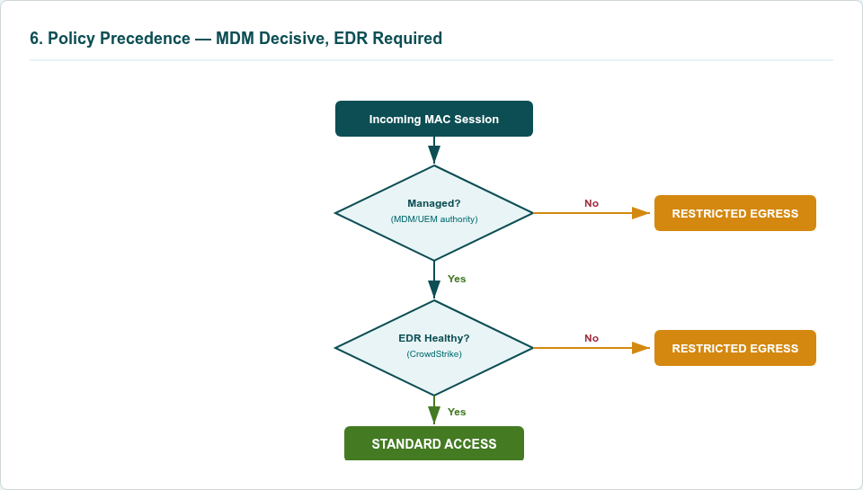

For managed endpoints, posture tier assignment incorporates additional signals from Qualys, Tanium, and ZIA. A device may be managed and EDR-healthy but still receive restricted access if it has critical unpatched vulnerabilities, is significantly out of compliance with configuration baselines, or has triggered internet threat detections through ZIA. The precedence is clear: MDM authority first, then EDR health, then vulnerability and compliance posture. Each layer can only restrict — never override the requirements of a higher-precedence layer.

4. Device Classification and Posture Model

4.1 Device Classification
Device classification follows a two-stage model. The first stage identifies the device's operating system and type through passive fingerprinting techniques — DHCP options, MAC OUI vendor identification, open ports, traffic patterns, and protocol analysis. The second stage determines the device's management status by querying authoritative MDM systems and correlating with the expected agent inventory. Together, these stages place every device into one of four classes, each with its own enforcement model and access default.
Device Class | Identification Method | Enforcement Model | Access Default
Managed Windows/macOS | OS fingerprinting + MDM enrollment + expected agent presence | Continuous three-tier posture enforcement | Tier-based: Full, Limited, or Restricted depending on posture
Unknown Windows/macOS | Windows/macOS detected but NOT in MDM/CMDB, missing expected agents | Deny or captive enrollment portal | Blocked until enrolled and agents deployed
IT IoT | DHCP fingerprinting, MAC OUI, protocols, behavioral profiling | Discovery-first, progressive governance with class-specific ACLs | Permissive initially; governed progressively as baselines mature
OT IoT | Protocol analysis (Modbus, BACnet, DICOM), vendor identification | Availability-prioritized governance with micro-segmentation | Profiled and baselined before enforcement; safety requirements preserved

4.2 Three-Tier Posture Framework
The posture framework assigns every managed endpoint to one of three tiers based on continuous evaluation of security agent health, MDM compliance, vulnerability exposure, configuration compliance, and internet threat posture. Each tier defines a specific set of access privileges that are enforced through RADIUS authorization attributes applied at the access switch.
Tier | Posture State | Access Privileges | Example Conditions
Tier 1 — Full Access | All agents healthy and current, MDM compliant, no critical vulnerabilities, trusted ZIA posture, no active security incidents | Unrestricted access to business resources subject to normal enterprise policy | All five security integrations (Forescout, CrowdStrike, Qualys, Tanium, ZIA) reporting healthy; MDM compliant; no open critical CVEs
Tier 2 — Limited Access | Partial compliance with one or more agents offline, outdated, or reporting issues; recent security events requiring restriction | Essential business applications and remediation infrastructure accessible; lateral movement to sensitive resources blocked | One agent offline or outdated; non-critical vulnerability exposure; recent ZIA threat event under investigation
Tier 3 — Restricted/Denied | Active compromise detected, critical unpatched vulnerabilities with known exploits, multiple agents offline suggesting tampering | Internet-only access via ZIA for remediation, or complete network denial depending on risk severity | CrowdStrike active detection (ransomware, lateral movement); multiple critical CVEs with public exploits; evidence of tampering
Tier assignment is continuous and dynamic. Posture is recalculated every 5–15 minutes for routine telemetry and in real time for security events. Access privileges automatically expand or contract without user or helpdesk intervention. A device that drops from Tier 1 to Tier 3 due to a CrowdStrike detection will be restricted within the target P95 latency of 15 seconds. A device that remediated a missing agent and returns to full compliance will be restored to Tier 1 on the next posture evaluation cycle.

5. Technical Enforcement Model

5.1 RADIUS MAB Authorization
RADIUS MAC Authentication Bypass is the authorization control plane. When a device connects to a wired port or associates with a wireless SSID, the switch or wireless controller initiates a MAB session and sends a RADIUS Access-Request to Forescout using the device's MAC address as the identity. Forescout evaluates the device's classification, queries MDM and EDR systems, aggregates posture telemetry, and returns a RADIUS Access-Accept with authorization attributes that direct the switch to apply the appropriate ACL or role.
Figure: End-to-End Data Path — Managed Device (Standard Access)
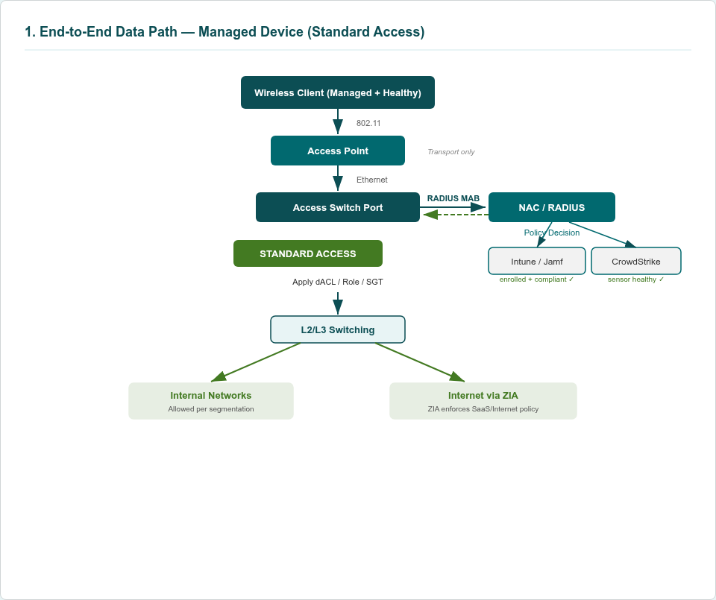

The choice of MAB over dynamic MAC ACL manipulation is deliberate and fundamental to the architecture. MAB is stateful, session-oriented, auditable, and revocable via Change of Authorization. Under MAB, the switch and NAC maintain a formal authorization state with a named policy, lifetime, and reason recorded in logs. Every session has a beginning, an active state, possible mid-session changes, and an end — each transition documented. Dynamic MAC ACL manipulation, by contrast, is mere configuration mutation — it lacks session state, standard reevaluation mechanisms, and reliable auditability.
Dynamic MAC ACLs are also prone to race conditions, policy drift, orphaned rules, and TCAM exhaustion in fast-changing wireless environments where devices associate and disassociate frequently. Without a session model, there is no reliable mechanism to clean up ACLs for devices that have left the network, leading to stale entries that consume finite hardware resources. MAB is the only approach that aligns with Zero Trust's demand for continuous verification and revocable authorization.
Authorization responses use Filter-ID attributes referencing pre-configured ACLs on the switch, or vendor-specific attributes for role or policy profile assignment. Tier 1 devices receive the FULL_ACCESS ACL permitting standard business access. Tier 2 devices receive the LIMITED_ACCESS ACL restricting lateral movement to sensitive resources. Tier 3 devices receive the INTERNET_ONLY ACL permitting only remediation traffic, or an Access-Reject denying all network access depending on risk severity.

5.2 Change of Authorization
After initial admission, Forescout continuously monitors device posture through agent telemetry and security tool integrations. When posture changes — CrowdStrike detects malware, Qualys identifies a new critical vulnerability, an MDM agent goes non-compliant, or Tanium reports configuration drift — Forescout initiates a mid-session policy change via RADIUS Change of Authorization (RFC 5176).
Figure: Decision & Authorization Sequence (MAB + NAC + Intune/Jamf + CrowdStrike + CoA)
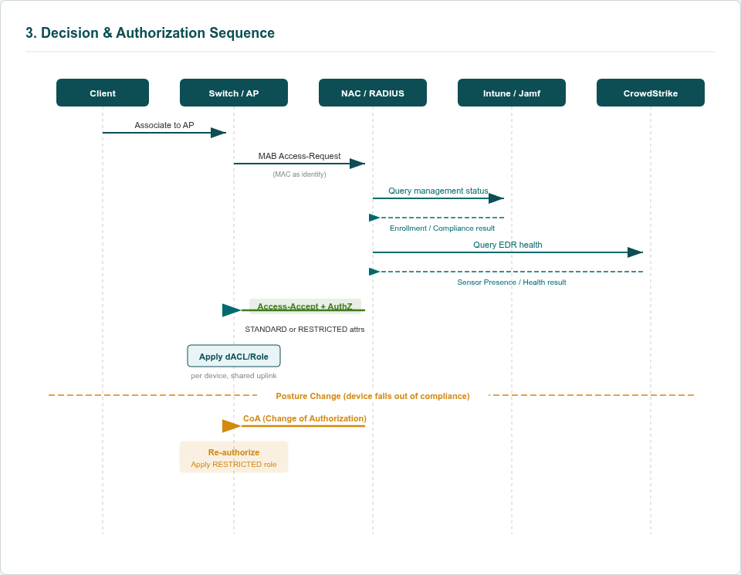

The CoA timing sequence proceeds as follows. At T0, the NAC platform detects a posture change through one of its integration channels. At T1, Forescout constructs and sends a CoA message to the access switch identifying the target session by MAC address and session ID. At T2, the switch processes the CoA message and re-authorizes the existing session without a link flap — the physical connection remains active throughout. At T3, the switch applies the new role, transitioning the device from its current tier (for example, STANDARD) to the appropriate restricted tier (for example, RESTRICTED EGRESS). At T4, the switch's new ACL takes effect: flows to internal RFC1918 address space stop; only ZIA, MDM/EDR management planes, DNS/DHCP, and PKI paths remain accessible. At T5, after the device remediates the posture issue, Forescout detects the improvement and sends another CoA restoring the standard role.
The target posture-to-enforcement latency is a campus-wide P95 of 15 seconds, measured from the moment the NAC detects a posture change to the moment the switch applies the new authorization. The switch must support RADIUS CoA (RFC 5176) and be configured to accept CoA messages from Forescout appliances on UDP port 3799.
Figure: CoA Timing Detail — In-Place Posture Flip
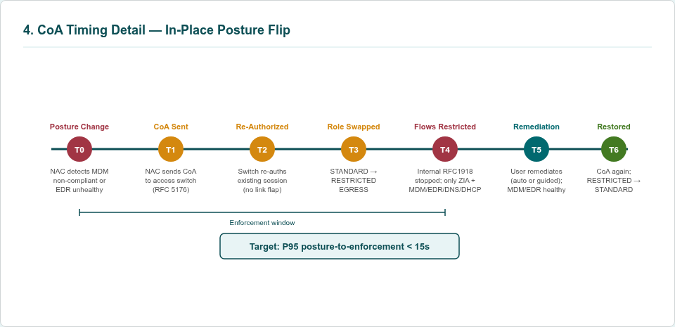

5.3 Restricted Egress
A central design choice is to define quarantine as a behavior rather than a network location. Instead of relocating non-compliant devices to a quarantine VLAN — which requires IP re-addressing, disrupts active sessions, and creates a single congested VLAN — the network applies a Restricted Egress role that constrains what the device can reach while keeping it on the same VLAN and IP address.
Figure: End-to-End Data Path — Unmanaged/Non-Compliant (Restricted Egress)
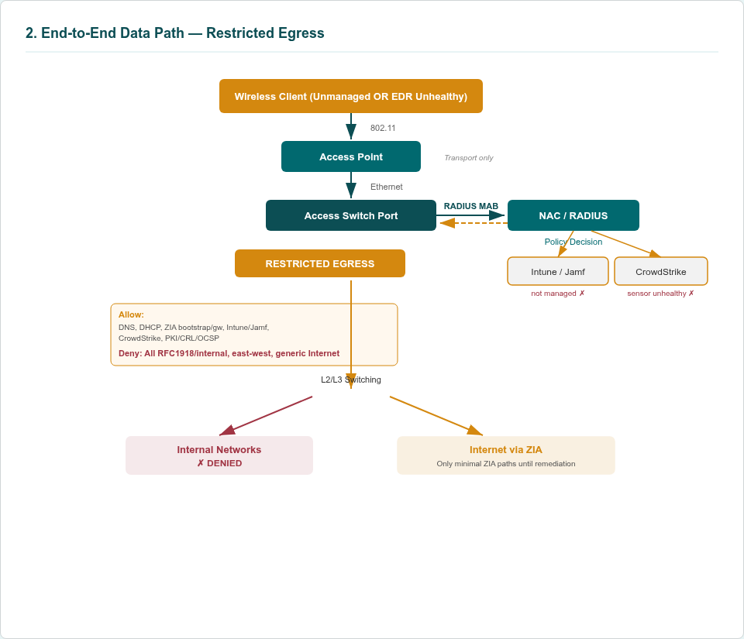

Restricted Egress permits the following traffic categories: DNS and DHCP for basic network operation and address maintenance; ZIA client bootstrap and gateway connectivity so the device can reach the internet through Zscaler for remediation activities; Intune and Jamf management planes for re-enrollment, compliance checks, and policy delivery; CrowdStrike cloud services for sensor repair, update, and telemetry submission; and PKI, CRL, and OCSP services where certificate validation is required for management plane connectivity.
Restricted Egress denies all internal RFC1918 and east-west traffic, preventing lateral movement to any internal resource. It also denies generic internet access that could bypass ZIA, ensuring that all internet-bound traffic passes through the organization's threat inspection and DLP controls.
This approach preserves the device's ability to remediate — the user still has functional internet through ZIA, can re-enroll in MDM, and can repair EDR — while eliminating internal lateral movement risk. The Restricted Egress allow-list is treated as policy-as-code, with automated ingestion of vendor-published endpoints (Microsoft publishes Intune endpoints, CrowdStrike publishes cloud service endpoints), CI-driven compilation of ACL objects, canary validation to detect regressions, and SIEM monitoring of deny logs for newly required destinations that may indicate endpoint changes.
Figure: Restricted Egress — Allow/Deny Overview
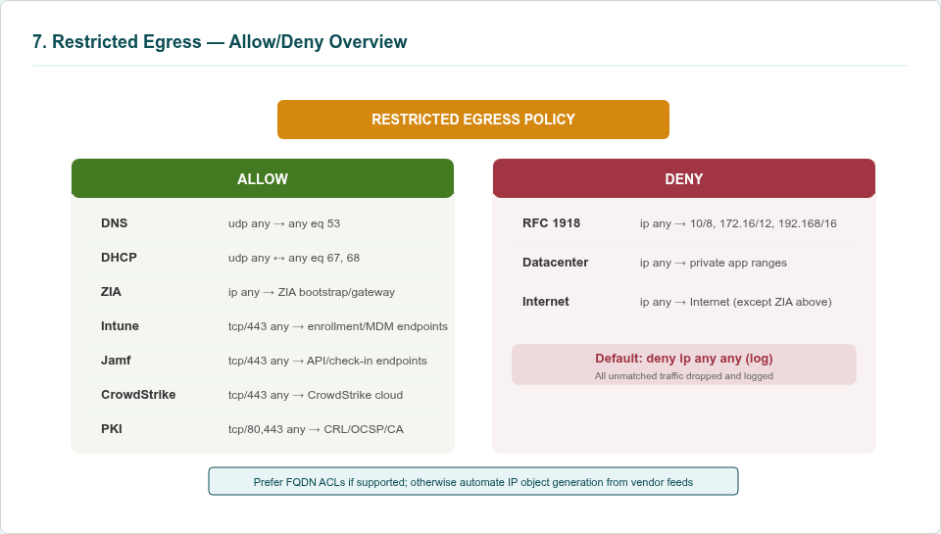

5.4 Per-Client Enforcement on Shared Uplinks
A critical technical requirement is per-device enforcement when multiple wireless clients share an AP uplink port. Modern access switches bind authorization to a client session keyed to the device's MAC address and, subsequently, IP address. Per-client dynamic ACLs, roles, or SGT rules are applied to each session independently within the switch's session table. The AP itself is never blocked; the switch selectively permits or denies flows from each client behind the port according to the individual authorization result.
Figure: Per-Client Enforcement on a Shared AP Uplink
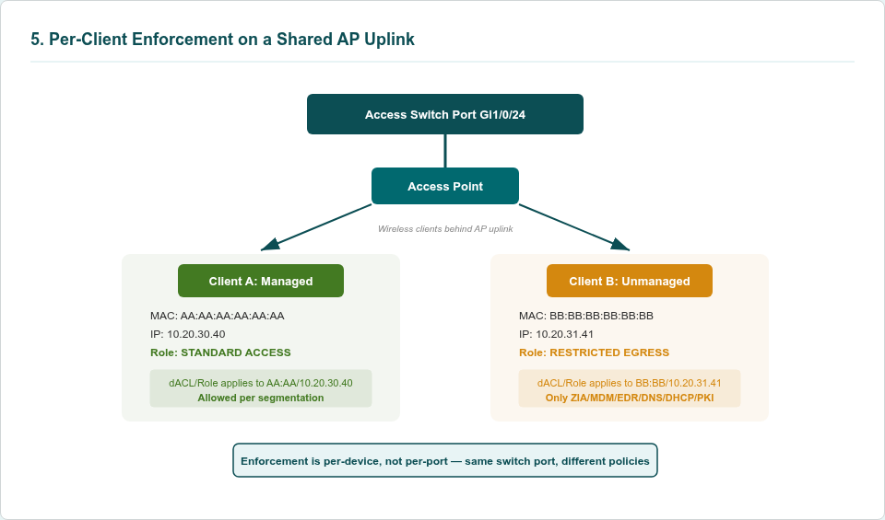

This means Client A — a managed, healthy endpoint — can receive full standard access while Client B — an unmanaged device — simultaneously receives Restricted Egress on the same physical uplink port. The enforcement is granular to the individual device, not to the port or AP. This capability is essential for wireless environments where dozens of devices share a single AP and a single uplink, and where blocking the port would affect all connected clients.

5.5 Fallback Enforcement
Where RADIUS CoA is unavailable, unreliable, or insufficiently granular, Forescout can use its Switch Plugin to push endpoint-specific ACLs directly to switches via SNMP, SSH, or vendor APIs. This approach is useful for legacy environments that do not support CoA and for certain IoT/OT use cases requiring highly specific, long-lived ACLs independent of session state. The Switch Plugin can write precise ACL entries targeting individual device MAC or IP addresses, providing enforcement for devices that do not participate in the RADIUS session model.
However, Switch Plugin enforcement does not scale as well as session-oriented RADIUS enforcement and requires write access to switch management interfaces, which introduces additional security considerations. It also lacks the session lifecycle management that MAB provides — there is no formal session start, change, or end, only configuration mutations. The primary enforcement model remains RADIUS-based; Switch Plugin enforcement is a documented fallback for specific, justified use cases.

5.6 Identity Hardening
MAC and IP correlation can be undermined by spoofing unless edge protections are in place. The program requires DHCP snooping on all access switches to build authoritative MAC-to-IP binding tables, and Dynamic ARP Inspection to validate ARP packets against those bindings and reject anomalies. These controls protect the session identity model that underpins all authorization decisions by ensuring that a device's claimed identity matches the identity observed by the network infrastructure.
Figure: Identity Hardening — DHCP Snooping + DAI
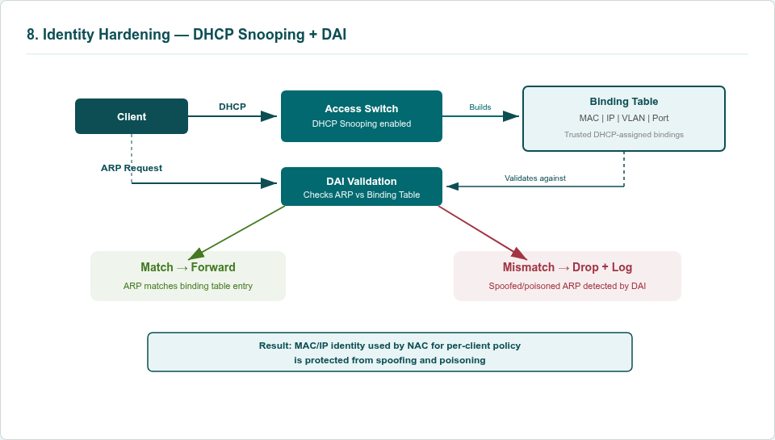

Combined with CrowdStrike's tamper protection, which raises the cost of sensor disablement and makes it detectable, and the requirement that managed status can only be confirmed by MDM — not merely by possessing a certificate or agent binary — the architecture significantly reduces identity-based evasion risk. An attacker who spoofs a managed device's MAC address will not have MDM enrollment, will not have a healthy CrowdStrike sensor, and will therefore be classified as an unknown device and denied access.

6. Observability and Governance

6.1 SIEM Correlation Model
The observability model aggregates telemetry from multiple layers into the enterprise SIEM for correlation and audit. Data sources include RADIUS authentication, accounting, and CoA logs from Forescout capturing every authorization decision and mid-session change; switch syslog showing authorization changes, ACL denies, and port state transitions at the enforcement point; MDM state snapshots from Intune and Jamf documenting compliance changes that triggered posture reevaluation; CrowdStrike sensor health and detection events correlating endpoint security incidents with network access decisions; and optionally ZIA egress logs for restricted clients showing what restricted devices attempted to access through Zscaler.
Figure: Observability & Audit Trace — SIEM Correlation Topology
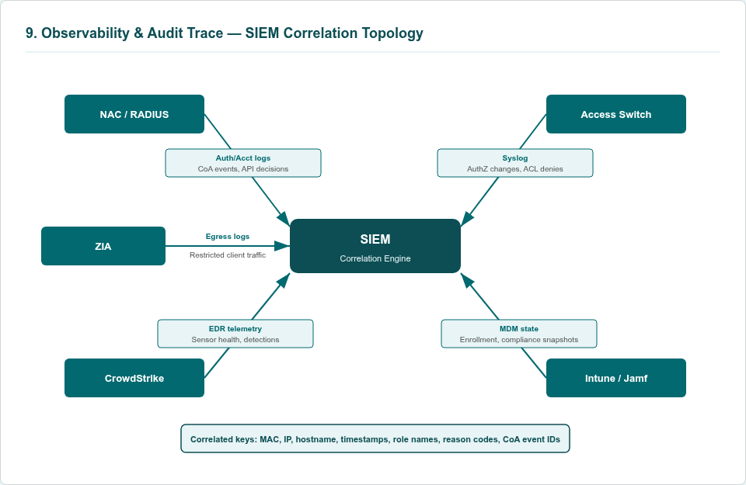

Correlation keys include MAC address, IP address, hostname or serial number, timestamps, role names, reason codes, and CoA event identifiers. These keys enable a complete audit narrative for any device at any point in time: what decision was made, when it was made, for which device, under which MDM and EDR conditions, and what network access was granted or denied as a result.

6.2 Exception and Break-Glass Management
Not all devices can achieve full compliance due to legacy constraints, vendor limitations, or operational requirements. A formal exception process governs deviations from standard posture requirements. Exception requests require documented business justification and a risk assessment that evaluates the security implications of granting non-standard access.
Approved exceptions receive a controlled Tier 2 profile with time-limited access requiring revalidation every 90 days, a restricted ACL tailored to the specific device's functional requirements, and enhanced monitoring including elevated logging and SIEM alerting. Exceptions are documented risk acceptances, not permanent bypasses, and each revalidation requires confirmation that the conditions justifying the exception still apply.
Break-glass access for emergencies is designed to be constrained in blast radius, time-boxed with automatic expiration, and subject to multi-party approval. Break-glass events generate elevated logging and are reviewed in post-incident analysis. Exception rates are tracked quarterly and expected to trend downward as legacy devices are retired or upgraded and as the program expands agent coverage and remediation automation.

6.3 Key Performance Indicators
The following KPIs provide quantitative measurement of the program's effectiveness and operational health.
KPI | Target | Measurement Method
Device classification accuracy | >90% within 30 days of deployment | Forescout classification vs. manual audit sample
Posture coverage for managed endpoints | >75% of managed endpoints with all agents reporting | Forescout posture dashboard
Time to restrict after posture failure | P95 <15 seconds campus-wide | CoA latency measurement in SIEM
Time to remediate back to standard | Median <4 hours | SIEM correlation of restrict-to-restore events
Percentage of endpoints healthy at connect time | >80% Tier 1 within 12 months | Forescout connect-time posture reports
Exception rate | <5% within 18 months | Exception registry quarterly review
Access-related support requests | 60–80% reduction from baseline | Helpdesk ticket tracking
Break-glass event frequency and duration | Trending downward; average duration <24 hours | SIEM break-glass event correlation

7. Failure Modes and Resilience
The architecture is designed to degrade gracefully under all foreseeable failure conditions. The governing principle is that the system never unintentionally fails open. Each failure mode has a defined behavior, documented runbooks with named owners, and accompanying user communication templates.
Figure: Failure Modes & Graceful Degradation — State Machine
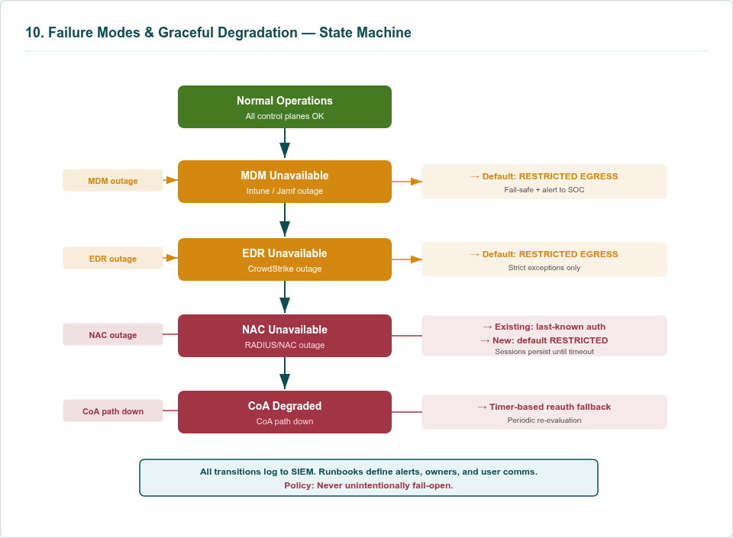

7.1 MDM Unavailable
When Intune or Jamf APIs are unreachable, Forescout cannot confirm whether a device is managed and compliant. In this state, new authorization decisions default to Restricted Egress for devices that cannot be positively identified as managed. Existing sessions retain their current authorization — the switch maintains the session state and the last-known-good authorization remains in effect. Alerts are generated for operations teams to investigate and resolve the MDM connectivity issue. The design does not infer managed status from cached data beyond defined staleness thresholds, typically 4–8 hours depending on the MDM platform, to prevent stale compliance data from granting inappropriate access.

7.2 EDR Unavailable
When CrowdStrike is unreachable, Forescout cannot verify sensor health or check for active detections. New sessions also default to Restricted Egress, with tightly controlled exceptions for business-critical segments. These exceptions are time-boxed, require explicit approval from security operations, and carry elevated monitoring to detect any security incidents that occur during the degraded period. The rationale is that without EDR verification, the organization cannot confirm that devices are free from active compromise, and the risk of granting standard access without that assurance is unacceptable.

7.3 NAC Platform Unavailable
If Forescout itself is degraded or unavailable, the architecture relies on two layers of resilience. First, existing sessions on switches keep their last-known-good authorization because the switch maintains the session state independently of the NAC. The session and its associated ACL remain active until the session ends or the reauthentication timer fires. Second, new sessions that cannot reach the RADIUS server will either default to Restricted Egress if the switch is configured with a fallback policy, or fall through to the critical VLAN if RADIUS is completely unreachable. The critical VLAN provides minimal connectivity to prevent complete business disruption while maintaining the most restrictive access possible.

7.4 CoA Path Degraded
If the CoA communication path between Forescout and switches is impaired — due to network issues, firewall misconfigurations, or switch processing delays — timer-based reauthentication provides a fallback enforcement mechanism. Each session has a configured reauthentication timer, typically 30–60 minutes. When the timer expires, the switch initiates a fresh RADIUS authentication for the session, and Forescout provides the updated authorization based on current posture. While this introduces latency compared to real-time CoA, it ensures that posture changes are eventually enforced even when the CoA path is unavailable.

7.5 Governing Principle
The system never unintentionally fails open. All failure transitions are logged to the SIEM with sufficient detail to reconstruct the timeline and understand the impact. Each failure mode is supported by documented runbooks with named owners, escalation paths, and resolution procedures. User communications templates are prepared for each scenario to ensure that affected users receive timely, accurate information about access restrictions and expected resolution timelines.

8. IoT and OT Governance Lifecycle
The IoT and OT governance lifecycle is a structured three-phase approach that progressively discovers, classifies, baselines, and governs non-managed devices across the enterprise. This lifecycle recognizes that IoT and OT devices cannot run standard security agents and must be governed through network-level controls informed by behavioral profiling and protocol analysis.

8.1 Phase 1 — Discovery and Profiling (Months 1–6)
Forescout passively discovers all devices on in-scope network segments via DHCP fingerprinting, ARP monitoring, SNMP polling, and traffic analysis. No active scanning is performed during this phase to avoid disrupting sensitive OT devices that may not tolerate unexpected network probes. Devices are classified using OS fingerprints, MAC OUI vendor identification, open ports, traffic patterns, hostnames, and protocol analysis including Modbus for industrial control systems, BACnet for building management systems, DICOM for medical imaging, and RTSP for surveillance cameras.
Each discovered device is tagged by function: printer, camera, VoIP phone, access control panel, HVAC controller, infusion pump, imaging system, badge reader, or other functional categories as they emerge. Enforcement remains permissive during this phase with existing VLAN ACLs in place to avoid operational disruption. The primary objective is inventory accuracy, not enforcement.
The deliverable for Phase 1 is a complete IT/IoT and OT/IoT inventory with 80 percent or greater classification confidence, traffic baselines per device type documenting normal communication patterns, and a risk-prioritized list of device classes for Phase 2 governance.

8.2 Phase 2 — Baseline Governance (Months 6–18)
Based on the traffic baselines established in Phase 1, functional ACL profiles are defined for each device class. These profiles restrict each device class to its documented communication requirements and deny all other traffic. Examples include printers restricted to print server communication on ports 515, 9100, and 631; surveillance cameras restricted to RTSP and ONVIF protocols communicating only with the video management system, with internet and east-west traffic denied; BMS controllers restricted to BACnet communication with their management station only; and medical devices restricted to HL7 and DICOM protocols communicating only with EMR and PACS systems.
ACLs are applied progressively, starting with the highest-risk and lowest-operational-impact device classes. Cameras and printers are typically governed first because they represent significant lateral movement risk with relatively low operational sensitivity. Critical OT devices — medical equipment, industrial control systems, and safety systems — are governed later after extensive baseline validation and stakeholder coordination. RADIUS returns class-specific Filter-ID attributes at connect time for each device class; CoA adjusts the ACL if device behavior deviates from the established baseline.
The deliverable for Phase 2 is 70 percent or greater of IT/IoT and OT/IoT devices under functional ACL governance with anomaly detection active, alerting on traffic patterns that deviate from established baselines.

8.3 Phase 3 — Continuous Validation (Months 18+)
Phase 3 establishes ongoing monitoring and governance for the IoT/OT device population. This includes detection of rogue devices appearing on the network without change management approval, behavioral anomaly detection for established devices that deviate from their baselined communication patterns, and monitoring of vendor vulnerability disclosures affecting specific device models in the inventory.
Zero-trust micro-segmentation is applied to critical OT systems during this phase. SCADA and safety systems are segmented from IT networks with firewall mediation, device-to-device communication is denied unless explicitly required and documented, and all permitted communication paths are monitored for anomalies. This represents the most restrictive governance posture and is applied only after extensive baseline data confirms that the segmentation will not disrupt critical operations.
The IoT/OT asset registry is maintained as a continuously updated source of truth linked to the CMDB. Each device entry includes ownership, business criticality, firmware version, vendor support status, and communication baseline. This registry supports incident response with real-time device context, compliance reporting with accurate asset inventories, and lifecycle management with firmware update and replacement planning.

9. Delivery Plan

9.1 Short-Term Delivery: Foundation and Pilot (Months 1–9)

Phase 1 — Foundation and Integration (Months 1–3)
The foundation phase establishes the NAC platform, integrates all security tool sources, and builds the initial device inventory in monitor-only mode. Key activities include:
- Define enforcement scope: document in-scope VLANs, subnets, SSIDs, and device classes with stakeholder approval. Scope definition is a formal deliverable requiring sign-off from network, security, and business stakeholders.
- Deploy Forescout appliances with RADIUS plugin; configure Forescout Segments for in-scope networks only. Appliance sizing and placement are determined by the number of devices and network segments in scope.
- Integrate with all security tools: Microsoft Intune, Jamf Pro, CrowdStrike Falcon, Qualys Cloud Agent, Tanium XEM, and Zscaler Internet Access. Each integration is validated independently before composite posture evaluation is enabled.
- Configure DHCP relay on switches and WLCs managing in-scope VLANs and SSIDs only. This ensures Forescout receives DHCP fingerprinting data for device classification.
- Deploy the Forescout agent to managed endpoints within scope to enable direct telemetry collection and agent-based posture verification.
- Operate in monitor-only mode with no enforcement. All posture evaluations are computed and logged but no RADIUS authorization or CoA actions are taken.
Deliverables: Approved scope definition, complete device inventory with OS classification, baseline posture tier assignments for all discovered devices, remediation report identifying Tier 2 and Tier 3 devices requiring attention before enforcement, ACL requirements per VLAN, and license consumption baseline.

Phase 2 — Enforcement Pilot (Months 4–6)
The pilot phase activates enforcement on a limited scope to validate the end-to-end workflow before broad deployment. Key activities include:
- Pre-configure ACLs on pilot wired switches and wireless roles on pilot WLCs. ACLs for each posture tier (FULL_ACCESS, LIMITED_ACCESS, INTERNET_ONLY) are deployed and tested.
- Configure Forescout as the RADIUS server for pilot VLANs and SSIDs. RADIUS authentication and accounting are enabled for pilot scope only.
- Enable connect-time enforcement (MAB + RADIUS authorization) for wired and wireless clients in pilot scope. Each connecting device receives its posture-based authorization at session establishment.
- Enable RADIUS CoA for continuous enforcement. Mid-session posture changes trigger real-time authorization updates.
- Pilot on low-risk in-scope VLANs and SSIDs including guest, contractor, and non-production segments where enforcement errors have minimal business impact.
Deliverables: Validated enforcement workflows for wired and wireless, user experience validation documenting the impact on end users, refined ACL definitions based on pilot observations, incident response playbooks for common scenarios, and license consumption tracking.

Phase 3 — Core Site Production Rollout (Months 7–9)
The production rollout phase expands enforcement to the initial target site population. Key activities include:
- Expand enforcement to 30 core corporate and back-office locations. Each site follows a standardized deployment playbook with 30–60 days of monitoring before enforcement activation.
- Configure ACLs and CoA on all production switches and WLCs at target sites. Configuration templates are developed from pilot learnings and applied consistently.
- Implement the exception workflow and governance processes including the exception registry, approval workflows, and revalidation schedules.
- Train helpdesk and SOC personnel on posture tiers, remediation workflows, exception handling, and escalation procedures.
Deliverables: 100 percent of managed endpoints at target sites under continuous NAC enforcement, populated exception registry, operational runbooks for all common scenarios, and a monthly metrics dashboard tracking KPIs.

9.2 Long-Term Delivery: Expansion and Maturity (Months 10–36)

Phase 4 — Specialty Location Expansion (Months 10–24)
The expansion phase extends NAC controls to specialty environments with unique device populations and operational requirements. Key activities include:
- Extend enforcement to specialty environments: high-value retail formats, specialized operations facilities, and OT-heavy environments including distribution centers, manufacturing sites, and healthcare facilities.
- Develop tailored IoT/OT governance profiles for each specialty location's device population, informed by Phase 1 discovery results and Phase 2 baseline data.
- Implement refined discovery scope controls for licensing efficiency, ensuring that only high-value segments consume Forescout licenses.
- Deploy micro-segmentation for high-value OT systems including SCADA, industrial control, and medical devices.
Deliverables: Consistent NAC controls across all access layers enterprise-wide, specialty IoT/OT governance profiles tailored to each environment, and an expanded asset registry covering the full device population.

Phase 5 — Optimization and Evolution (Months 12–36, overlapping)
The optimization phase runs concurrently with expansion and focuses on improving enforcement quality, reducing exceptions, and evolving the enforcement model. Key activities include:
- Tune posture policies based on operational experience, adjusting thresholds, timing, and conditions to optimize the balance between security rigor and operational impact.
- Reduce exception rate through device upgrades and agent deployment, targeting less than 5 percent of managed devices requiring exceptions within 18 months.
- Implement automated remediation workflows leveraging Tanium for patch deployment and agent reinstallation, reducing mean time to remediation.
- Enhance Forescout-ZIA bidirectional integration for unified LAN and SaaS policy, enabling LAN posture to inform Zscaler access decisions and vice versa.
- Migrate enforcement from dynamic ACLs to role abstraction (Phase 2 of the evolution roadmap), simplifying policy management and reducing ACL sprawl.
- Begin SGT/TrustSec identity tag evaluation and pilot where hardware supports it (Phase 3 of the evolution roadmap), testing identity-based segmentation at the network edge.
- Conduct tabletop exercises for incident response scenarios testing the full workflow from detection through containment to remediation and restoration.
Deliverables: 80 percent of devices at Tier 1 posture, automated remediation reducing MTTR by 50 percent or more, documented case studies of prevented lateral movement, role-based enforcement operational across core sites, and SGT pilot results informing the long-term enforcement roadmap.

9.3 Evolution Roadmap
The enforcement model is designed to evolve through three phases, each building on the previous one without changing the underlying trust model or disrupting existing controls.
Figure: Evolution Roadmap — dACL → Role → SGT/TrustSec
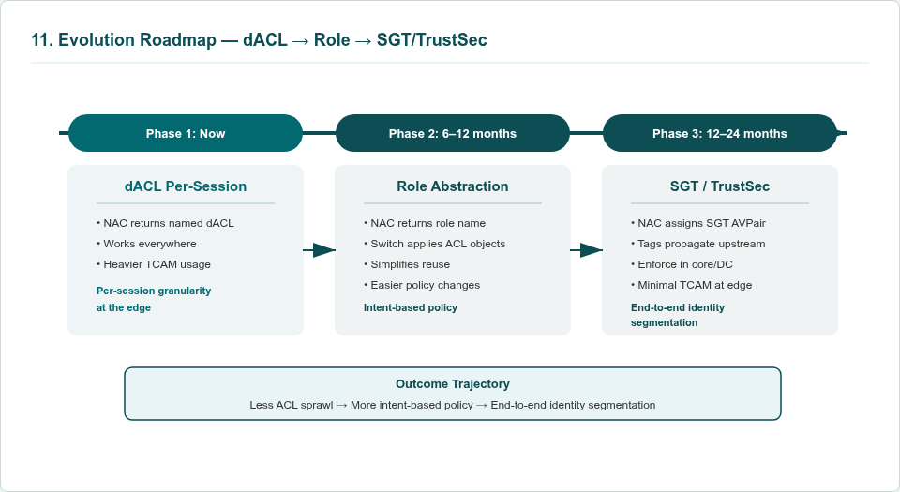

Phase 1 (Current): Per-session named dACLs. The NAC returns a named dynamic ACL that the switch applies to the individual session. This approach works broadly across current switch platforms and provides granular per-device enforcement. However, it consumes more TCAM resources on the switch and creates ACL sprawl at scale as the number of unique ACL definitions grows with the device population.
Phase 2 (6–12 months): Role abstraction. The NAC returns a role name and the switch applies reusable ACL objects referenced by that role. Multiple devices with the same posture tier share the same role and therefore the same ACL entries, dramatically reducing TCAM consumption and ACL duplication. Policy changes are faster and safer because updating a role definition automatically applies to all sessions using that role.
Phase 3 (12–24 months): SGT/TrustSec identity tags. The NAC assigns a Security Group Tag as a RADIUS AV-pair. Tags propagate upstream through the network, enabling policy enforcement beyond the access edge — at distribution, core, and data center boundaries — with minimal TCAM pressure at the edge. This extends the Zero Trust enforcement model from the access layer to the entire network fabric.
The trajectory is clear: less ACL sprawl, more intent-based policy, and eventually end-to-end identity-based segmentation. Throughout all phases, MAB remains the edge authorization plane and CoA remains the runtime enforcement lever. The trust model does not change; only the mechanism for expressing and enforcing policy evolves.

10. Risk Register
The following risk register documents the primary risks to program success, their assessed likelihood and impact, and the mitigation strategies in place or planned.
Risk | Likelihood | Impact | Mitigation
Allow-list brittleness (ZIA, Intune, Jamf, CrowdStrike endpoints evolve) | Medium | High | Automated ingestion of vendor-published endpoints; CI-driven object regeneration; canary validation; SIEM deny-log monitoring for newly required destinations
Vendor capability variance across switch hardware | Medium | Medium | Policy abstraction in NAC to render platform-specific constructs; hardware roadmap prioritizing CoA reliability, per-client dACL scale, and SGT support
Identity spoofing (MAC randomization, ARP poisoning) | Low | High | DHCP snooping and DAI on access switches; EDR tamper protection; MDM-only authority for managed status reduces spoofing value
Licensing cost overrun from scope creep | Medium | Medium | Scoped discovery limited to defined segments; quarterly scope review; cost-benefit analysis required for expansion
Operational complacency and break-glass overuse | Medium | Medium | Governance metrics, exception review cadence, time-boxing with elevated approval, quarterly KPI reporting
CoA reliability at scale during mass posture events | Low | High | CoA queueing and retry logic in Forescout; switch dynamic-authorization hardening; timer-based reauth fallback; load testing during pilot
Agent coverage gaps degrading posture accuracy | Medium | High | Pre-enforcement agent gap remediation; monitoring dashboards for agent health; automated reinstallation workflows via Tanium

11. Organizational Readiness
Successful deployment of the NAC architecture depends on coordinated preparation across multiple organizational functions. Technical controls alone are insufficient — the program requires operational readiness, process maturity, and executive support to achieve its objectives.

11.1 Network Team Preparation
Layer 2 switch and wireless controller configuration changes — including DHCP relay, MAB enablement, RADIUS server configuration, CoA acceptance, and ACL deployment — require coordinated planning and change control across all target sites. Per-site change sets must be developed from standardized templates, tested in a lab environment that replicates the production switch platform, and executed in scheduled maintenance windows with rollback procedures documented and tested. Network engineering resources must be allocated for each site deployment wave, and the team must be trained on the NAC enforcement model to effectively troubleshoot issues during and after activation.

11.2 Security Tool Health
Posture enforcement depends on agent coverage and telemetry quality from CrowdStrike Falcon, Qualys Cloud Agent, Tanium XEM, and Zscaler Client Connector. Agent coverage gaps must be identified and remediated before enforcement activation at each site. This requires coordination with desktop engineering teams to deploy missing agents, resolve agent health issues, and ensure that all managed endpoints are reporting telemetry to the platforms that Forescout will query for posture evaluation. A site is not ready for enforcement activation until agent coverage meets the minimum threshold defined in the deployment readiness criteria.

11.3 Helpdesk and SOC Readiness
Support staff require training on posture tiers, the remediation workflow (how users resolve common posture issues), and the exception process (how to request and approve exceptions for devices that cannot achieve compliance). The SOC must integrate Forescout alerts into SIEM workflows, develop incident response playbooks for NAC-specific scenarios such as mass posture events and false positive investigations, and establish escalation paths for issues that require NAC policy changes or exceptions.

11.4 Executive Sponsorship
Enforcement activation will initially restrict non-compliant devices, which may include devices used by senior leaders and critical business functions. Leadership support is critical for managing change resistance, maintaining enforcement discipline when pressure builds to create exceptions, and communicating the security rationale to affected users. Executive sponsorship must be explicit and documented before enforcement activation begins.

11.5 Phased Enforcement Activation
Each site operates in monitoring mode for 30–60 days before enforcement activation. During this period, the NAC evaluates all devices and computes posture tiers, but no access restrictions are applied. This monitoring phase identifies devices that would be restricted under enforcement, allowing teams to remediate posture issues proactively and preventing unexpected business disruption when enforcement is activated. Sites that do not achieve the minimum readiness criteria during the monitoring phase are held for remediation before proceeding.

11.6 Resource Requirements
The program requires the following organizational resources to execute successfully:
- Forescout platform team: 2–3 FTEs for policy development, integration configuration, posture rule tuning, and day-to-day operational support of the NAC platform.
- Network engineering: Resources as needed per site for switch and wireless controller configuration, allocated in coordination with the deployment wave schedule.
- Security operations: Integration of Forescout alerts into SIEM and SOC workflows, development of incident response playbooks, and ongoing monitoring of NAC-related security events.
- Endpoint management: Coordination with desktop engineering teams to resolve agent coverage gaps, deploy missing security agents, and ensure all managed endpoints meet minimum posture requirements before enforcement activation.

